General results: Figures and Graphs

Figure 1: Histogram of all ASWell scores
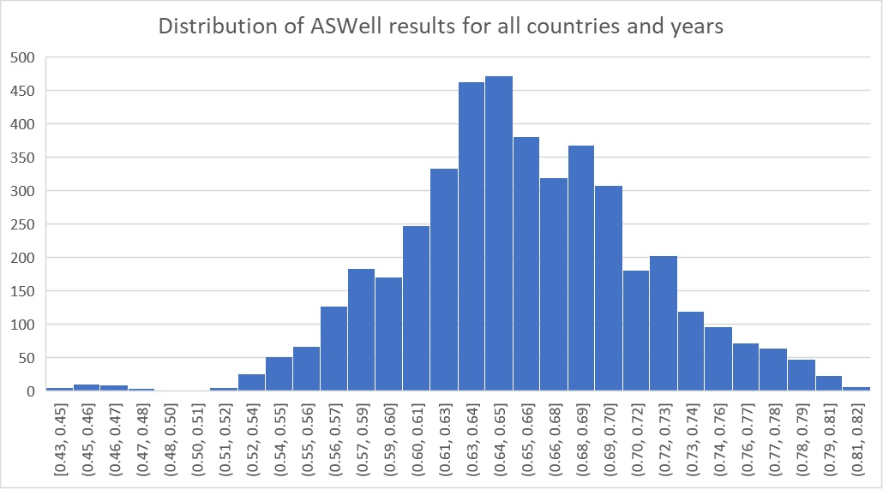

Figure 2: Histogram of averaged ASWell scores
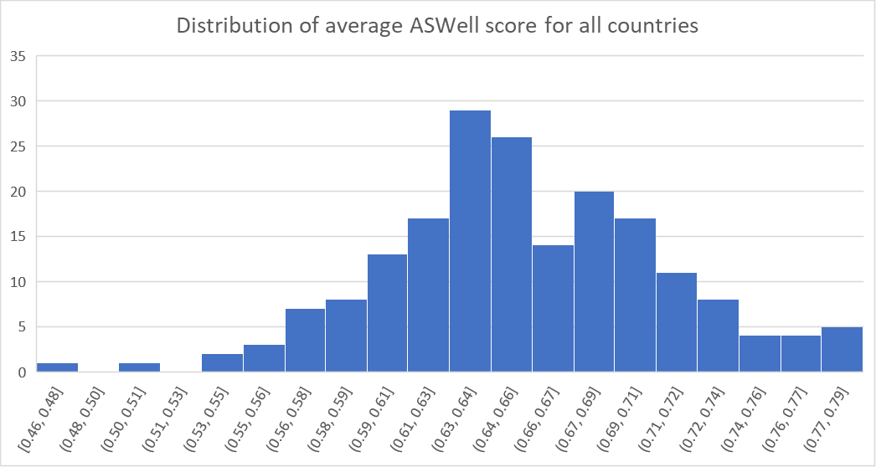

Figure 3: World map indicating average ASWell Index scores for all 190 countries from 2000 to 2022.
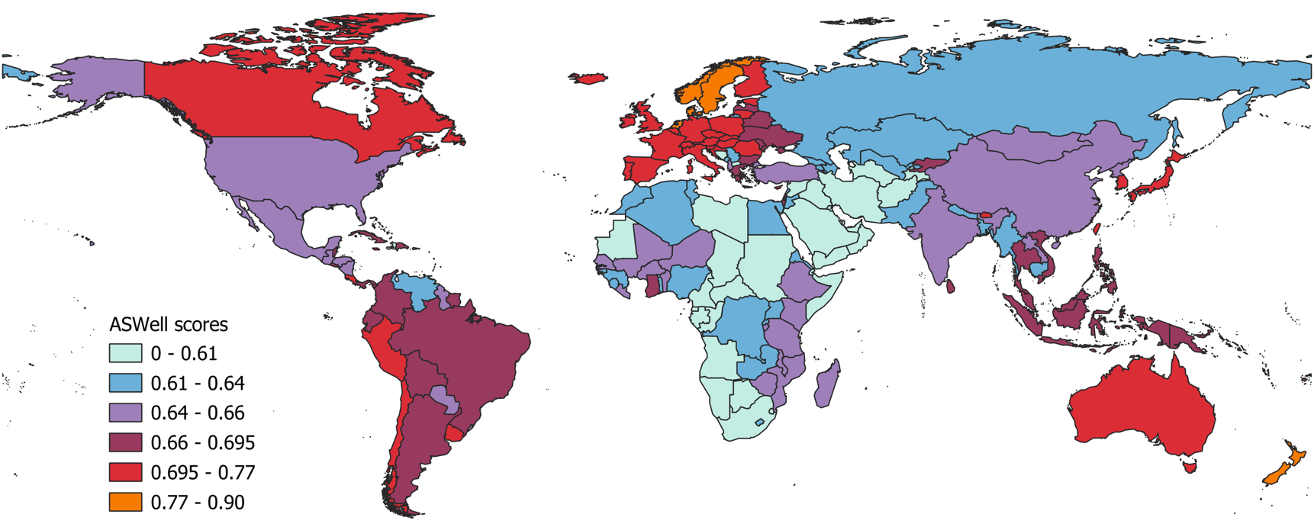
This world map shows average ASWell scores from 2000 to 2022 for 190 countries colour-coded based on quintiles, excluding the top five scoring countries of the ASWell, which have been clustered separately.

Figure 4: Map of Europe and parts of Central Asia indicating average ASWell Index scores for these countries from 2000 to 2022.
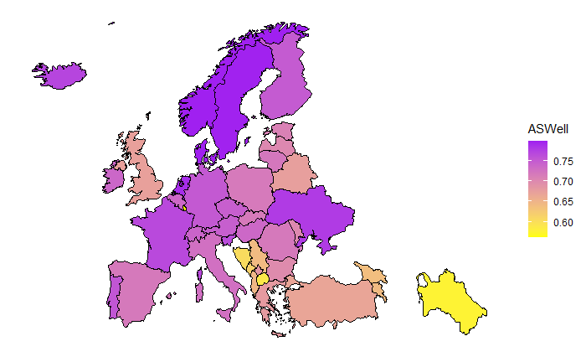

Figure 5: Map of Middle East and North Africa indicating average ASWell Index scores for these countries from 2000 to 2022.
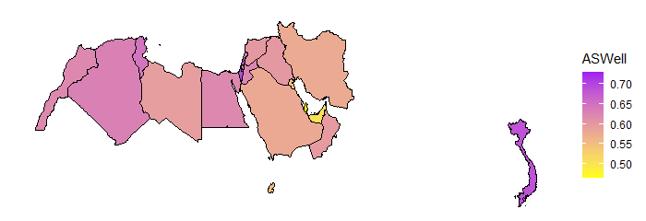

Figure 6: Trend of ASWell scores over time (2000-2022) on the world level
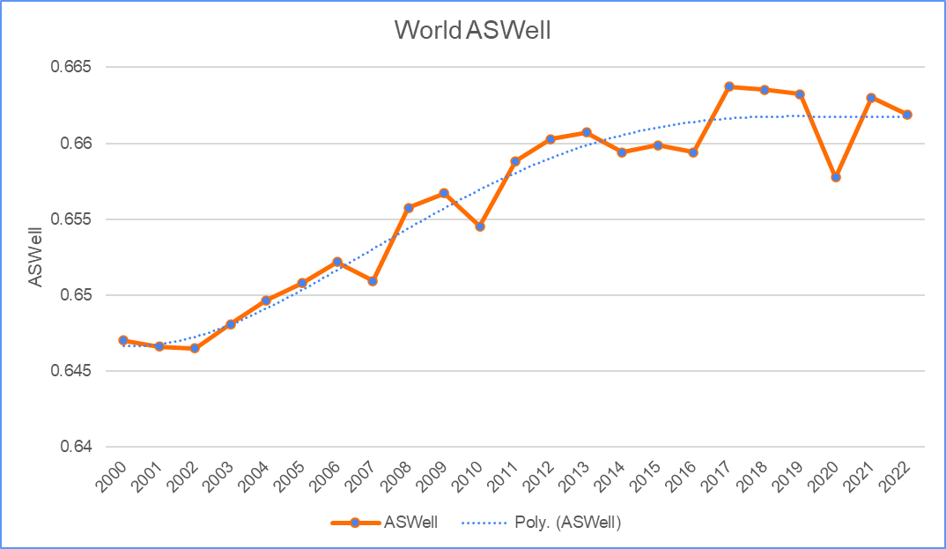

Figure 7: Top 5 scoring countries ASWell Index plotted with GDP/capita across time (2000-2022)
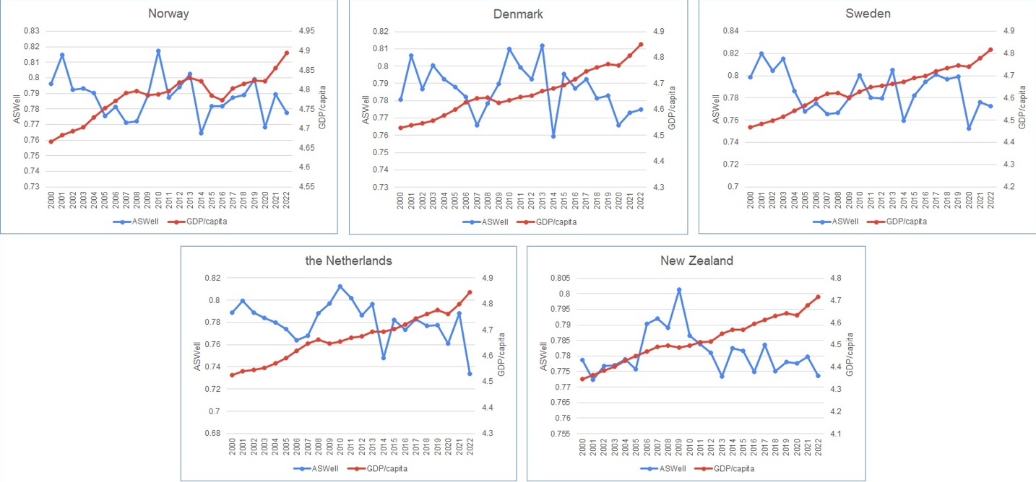
(From highest to lowest: Norway, Denmark, Sweden, the Netherlands, New Zealand)

Figure 8: Bottom 5 scoring countries ASWell Index plotted with GDP/capita across time (2000-2022)
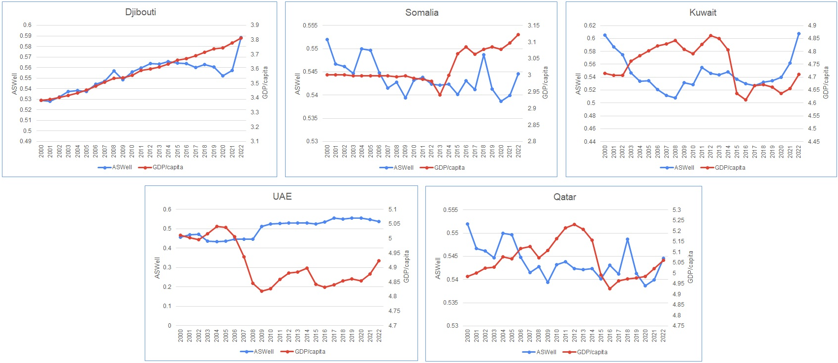
(From highest to lowest: Djibouti, Somalia, Kuwait, UAE, Qatar)

Figure 9: Top 5 scoring countries in GDP/capita plotted with the ASWell across time (2000-2022)
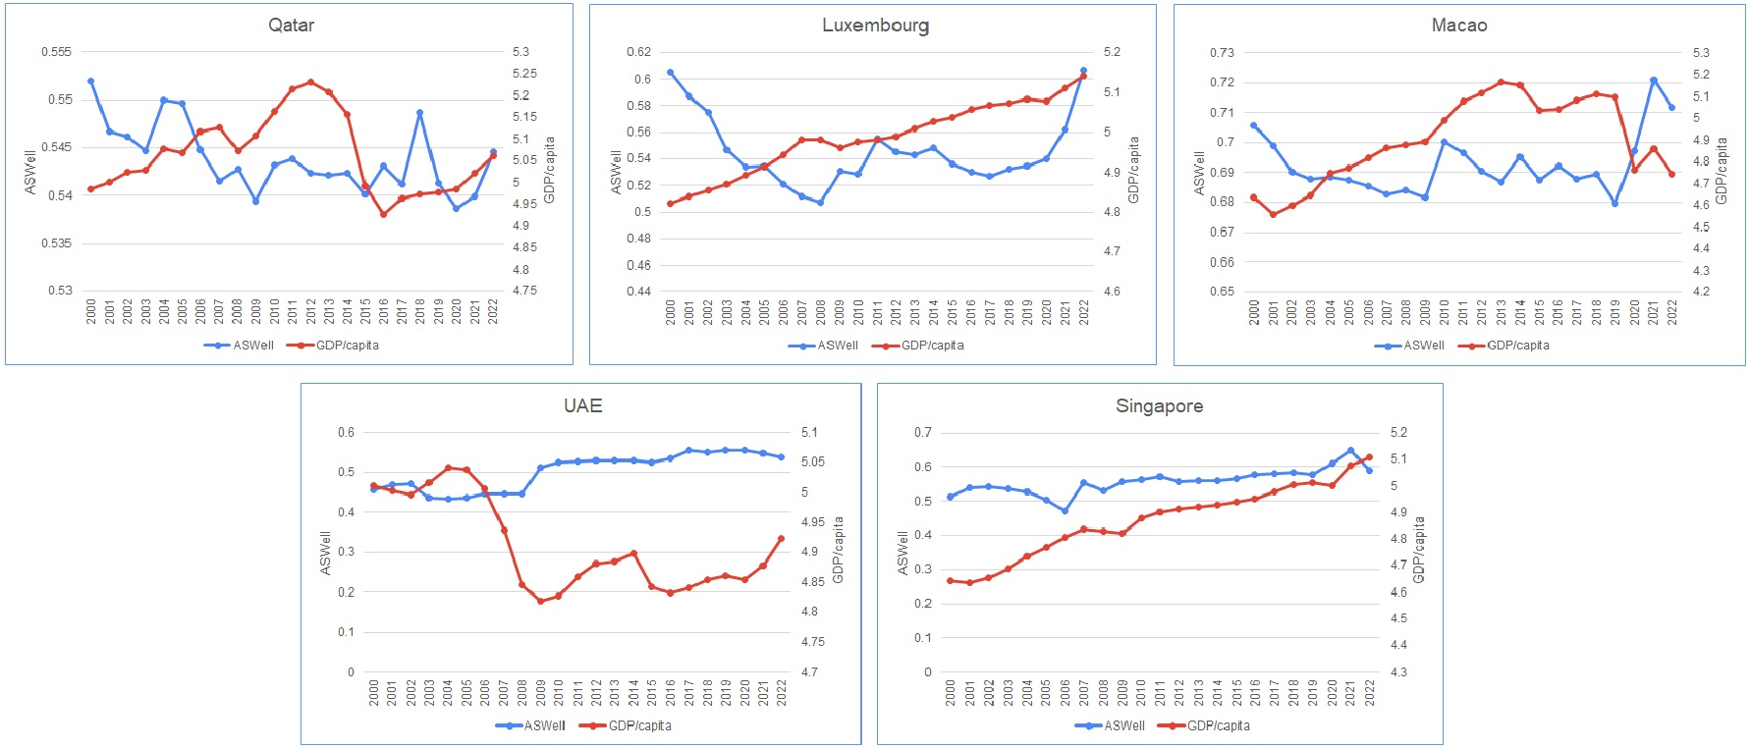
(From highest to lowest: Qatar, Luxembourg, Macao, UAE, Singapore)

Figure 10: Bottom 5 scoring countries in GDP/capita plotted with ASWell across time (2000-2022)
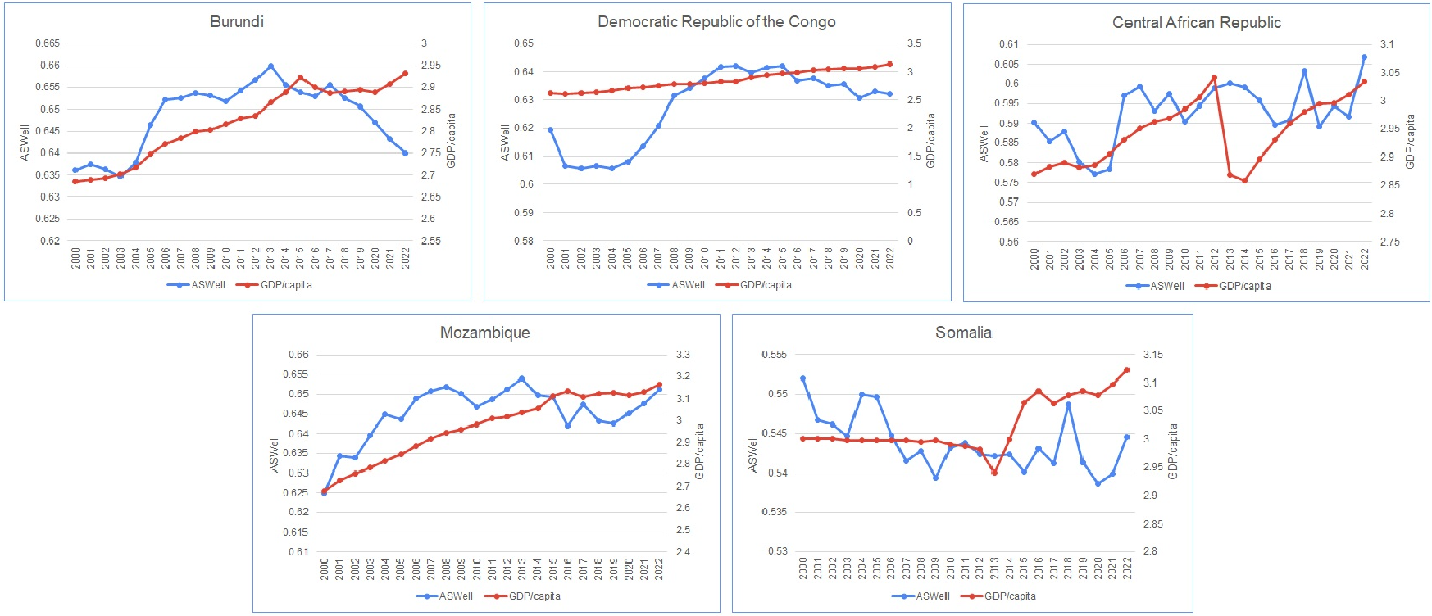
(From lowest to highest: Burundi, Democratic Republic of the Congo, Central African Republic, Mozambique, Somalia)

Figure 11: ASWell and GDP/capita plotted across time (2000-2022) per world region
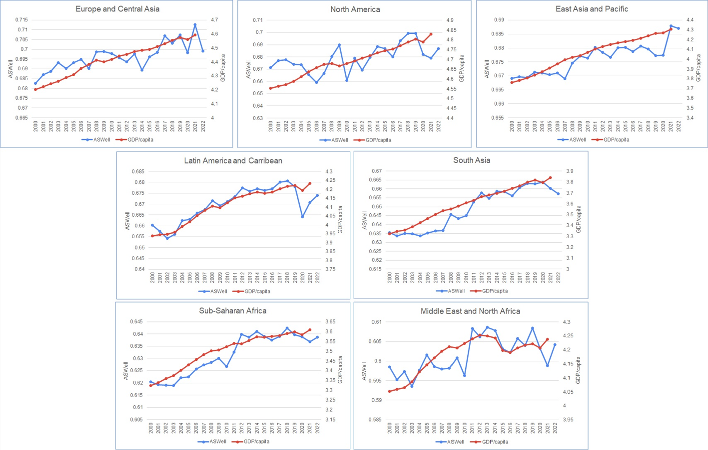

Figure 12: ASWell and GDP/capita plotted across time (2000-2022) each other for the world
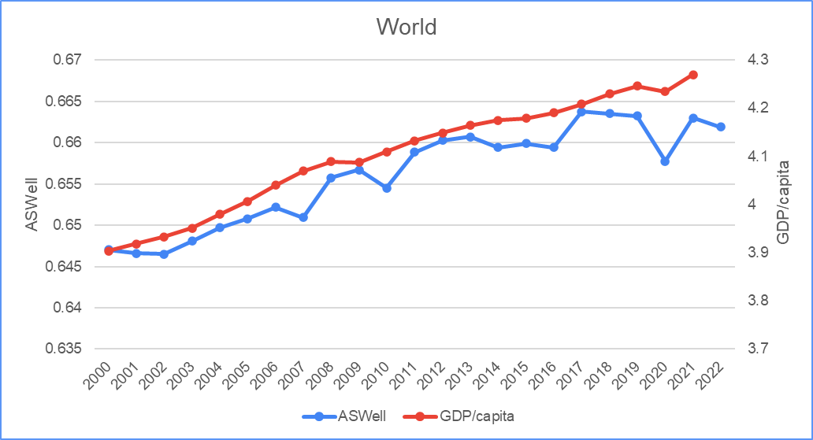
Figure 13: Qatar plotted for the ASWell and GDP/capita across time (2000-2022) with polynomial trendlines added for each indicator
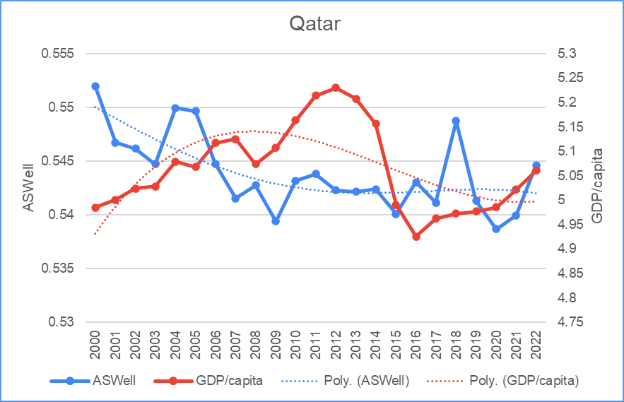

Figure 14: Kuwait plotted for the ASWell and GDP/capita across time (2000-2022) with polynomial trendlines added for each indicator
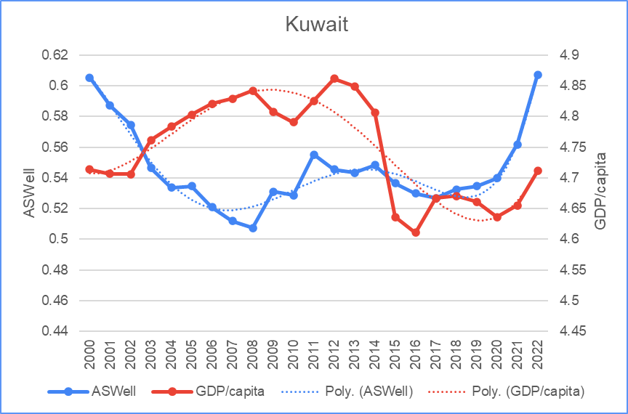

Table 1: Top 5 highest and lowest scoring countries for the ASWell and GDP/capita on average across the years 2000-2022

Top 5 ASWell | Bottom 5 ASWell
- Norway (0.798)  - Denmark (0.798)  - Sweden (0.797)  - The Netherlands (0.790)  - New Zealand (0.788) | - Djibouti (0.555)  - Somalia (0.548)  - Kuwait (0.548)  - United Arab Emirates (0.503)  - Qatar (0.465)
Top 5 GDP/capita (in thousands) | Bottom 5 GDP/capita (in thousands)
- Qatar (1118,2)  - Luxembourg (989,6)  - Macao (861,1)  - United Arab Emirates (826,8)  - Singapore (777,1) | - Somalia (1,067)  - Mozambique (0,995)  - Central African Republic (0,884)  - Dem. Rep. of the Congo (0,769)  - Burundi (0,671)

